IPTV

Overview
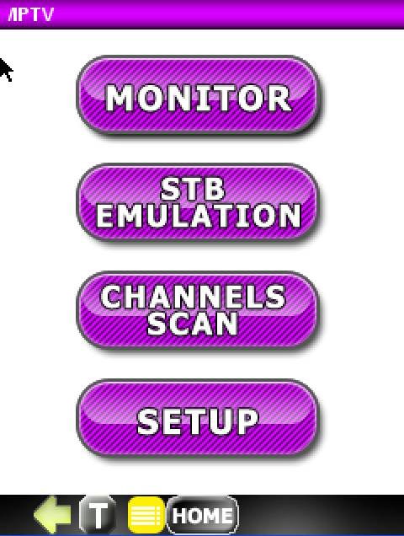
The IPTV application has three modes of operation:
- Set Top Box (STB) EMULATION - allows you to emulate a STB with simultaneous IPTV multicast streams (up to 40 Mbit/s bandwidth, typically 5-6 SD streams or 1-2 HD streams). It also supports passive monitoring during STB emulation.
- Monitor – allows you to passively monitor IPTV multicast streams.
- CHANNELS SCAN allows you to check the availability of multicast streams in a network. User can define a list of multicast streams that should be verified.

All modes require terminating the DataScout 1G LAN 10/100 port on the STB or Gateway port.

Acquiring an IP Address
Prior to using the IPTV option, the DataScout 1G has to establish an IP address via the LAN 10/100 port with the network. Reference Chapter – 14 Acquiring an IP Address. The example below uses DHCP.
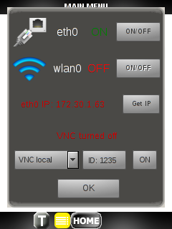

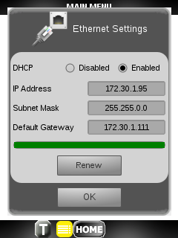

SETUP
Configuring IPTV setup is simple.
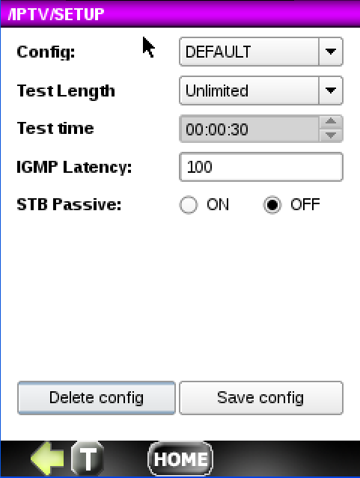
- Config: Choose a setup configuration from the list of previously saved configs or leave the default.
- Test Length: Select the duration for the test. Choices include 30 s, 1 min, 5 min, 10 min, 30 min, 1 h, 3 h, 6 h, 12 h, 1 day, 2 days, 3 days, User Def. The default is Unlimited.
- Test Time: If the Test Length is set to User Def, you can enter the test time as hr:min:s.
- IGMP Latency: Enter a value for the period of time (in milliseconds) for the CHANNEL SCAN to send an IGMP JOIN request for each channel on the CHANNEL LIST.
- STB Passive: Turn this radio button ON to passively monitor and analyze channels during STB emulation.
- Save this configuration if desired.
Saving the SETUP
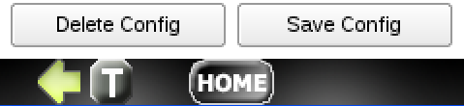
The buttons labeled Delete Config and Save Config allow you to delete and save any configuration file currently shown in the Config window. If the config is not saved, it will retain the last config used.
To save a config, press the Save Config button.
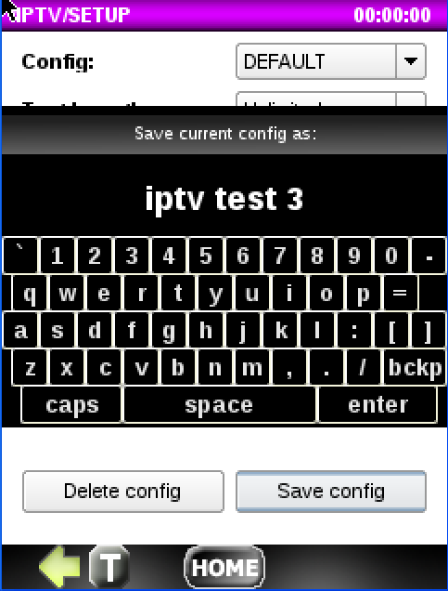
You can save as Default or you can enter a new name for the current configuration. To save, press the enter button.
When you return the Setup menu, you will see any new configs created in the Config drop down.

STB Emulation
In the STB EMULATION mode, the DataScout 1G connects as the end-device to emulate a Set-Top Box (sending an IGMP join). The application supports UDP/ MPEG-2 TS & UDP/RTP/MPEG-2 TS network protocols stacks.
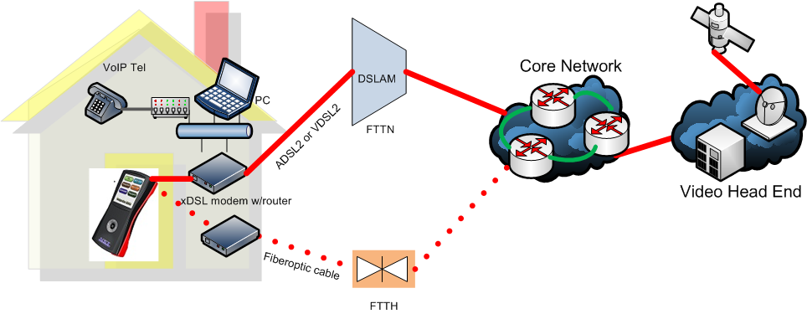

Build or Import Channel List

Prior to starting STB emulation, your DataScout 1G needs a Channel List. This list includes the channel numbers and IP addresses that will be used for testing. The list can be entered manually or imported via the DataScout 1G’s USB port.
Press the Channel List button to display the CHANNEL LIST management menu. Use this menu to enter channels manually, import a channel list via the DataScout 1G’s USB port or to edit an existing Channel List.
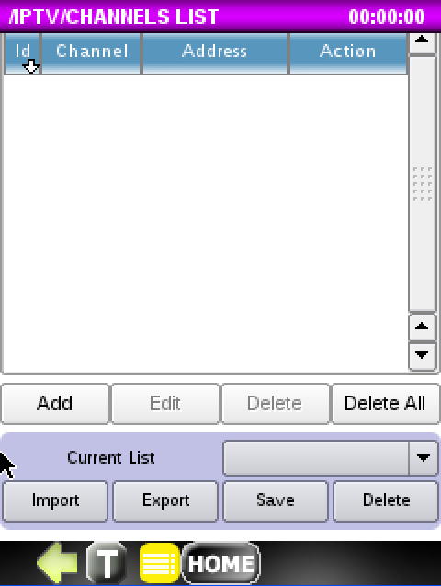
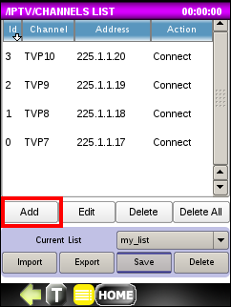
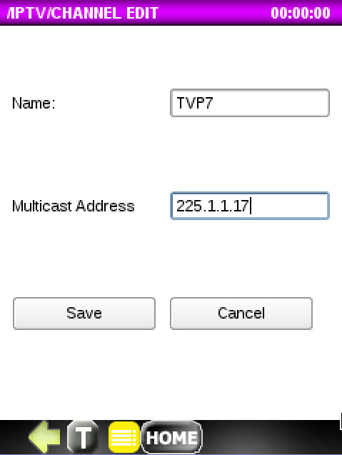
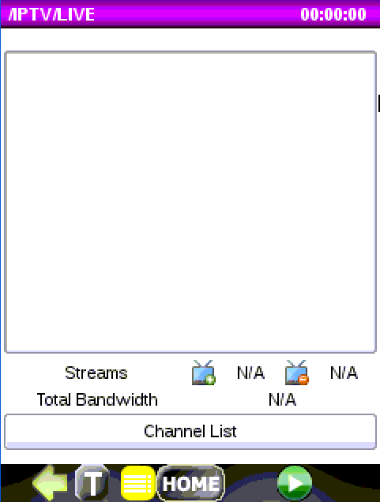
To add channels:
- Click on the Add button
- Enter the Channel Name, Multicast Address and press Save

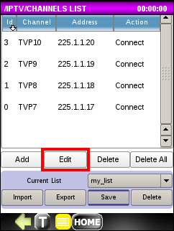
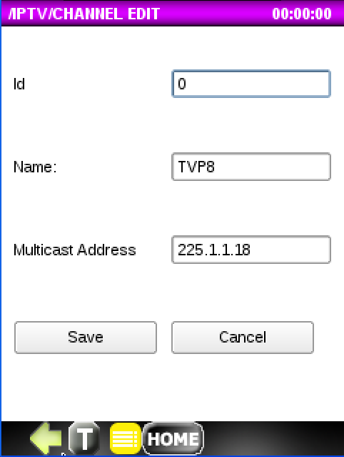
To edit channels:
- Select a channel on the Channels List to edit by clicking on it.
- Edit the channel and press Save

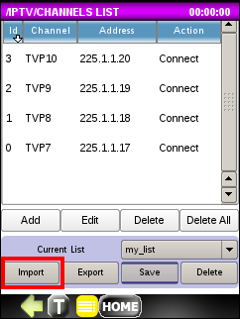
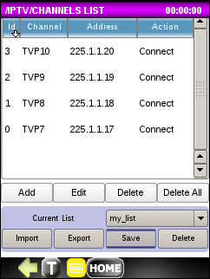
To import channels:
- Insert USB disk into the mini-USB adaptor.
- Click on the Import List button.
- Choose the list to import.
- The file should be of the format: 1;225.1.1.1;TVP1

Request Connections
Once you load the Channel List, the action for each channel will display an action of Connect. Click on the Connect text to toggle it to Disconnect. This indicates that when you start STB emulation, you are going to request to connect to this channel. You can actually request to Connect to multiple channels simultaneously depending on the bandwidth used. We recommend not exceeding 40Mbps.

Running STB Emulation

- Prior to running STB emulation, your Channel List must be loaded and you must choose which channels you wish to Connect. See previous section Build or Import Channel List.
- Press on the button to start the emulation test. If you are at the Channels List screen, press the button to reach the LIVE screen.
- Wait until the list of connected channels appears.
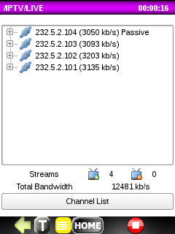

The example screen above displays a list of connected streams. Click on the “+” to expand the tree with information about PID numbers inside the stream such as:

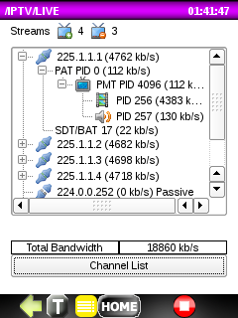
- PID type(table like PAT/PMT/… and audio/video data)
- PID number
- bandwidth for each PID respectively.
- Total bandwidth for all connected channels (Note: if the total bandwidth exceeds 40mbps the excess channels will be disconnected.)

At any time during the test, channel the Connect/Disconnect status on the Channel List can be manually changed.
If there are other streams present in the link than those listed on the Channel List, they will be shown as passive if Passive Monitoring is enabled in Setup.

Detailed Results

To see detailed results, user should click on the specified node of stream tree on the LIVE screen and then press the right arrow to navigate to the STATISTICS screen. For each PID and also for whole stream, detailed metrics and status information are presented on three tabs labeled Basic, Packets and TR101290.
Basic Tab
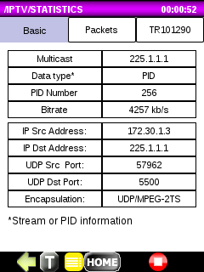
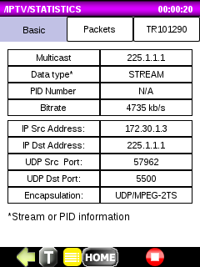
This tab provides information about the STREAM or PID within the STREAM including:
- multicast address
- data type (stream/pid)
- pid number only for PID
- bitrate
- ip source & destination address
- udp source & destination address

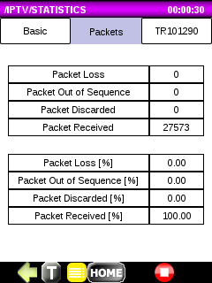
Packets Tab
This tab provides information about the STREAM packet statistics including:

- Packet Loss (Total and % ratio)
- Packet Out of Sequence (Total and % ratio)
- Packet Discarded (Total and % ratio)
- Packet Received (Total and % ratio)

TR101290 Tab
This tab provides information about the TR101290 Priority 1 and Priority 2 stream metrics including:
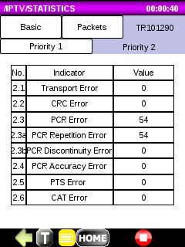
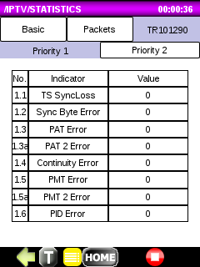
Priority 1 metrics:
TS Sync Loss, Sync Byte Error, PAT Error, PAT 2 Error, Continuity, Error, PMT Error, PMT 2 Error, PID Error
Priority 2 metrics:
Transport Error, CRC Error, PCR Error, PCR Repetition Error, PCR Discountinuity Error, PCR Accuracy Error, PTS Error, CAT Error,

Monitor
The Monitor function allows you to passively monitor and analyze IPTV multi-cast channels that are received at the DataScout 1G 2000 10/100 LAN port. If your network segment transmits IPTV streams on every switch port, you can just connect to a switch port and monitor. Otherwise, you will need a hub or TAP device to monitor data between the modem/router and STB.
Press on the button to start the Monitor. Wait until at least one passively monitored stream displays.
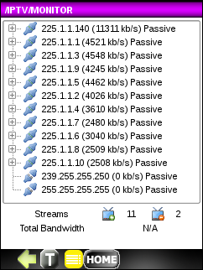

The example screen above displays a list of connected streams. Click on the “+” to expand the tree with information about PID numbers inside the stream such as:
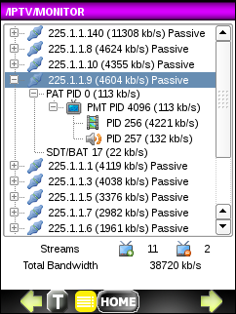
- PID type(table like PAT/PMT/… and audio/video data)
- PID number
- bandwidth for each PID respectively.
- Total bandwidth for all connected channels (Note: if the total bandwidth exceeds 40mbps the excess channels will be disconnected.)

Detailed Results

To see detailed results, user should click on the specified node of stream tree on the Monitor screen and then press to navigate to the STATISTICS screen. For each PID and also for whole stream, detailed metrics and status information are presented on three tabs labeled Basic, Packets and TR101290.
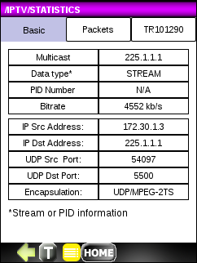
Basic Tab
This tab provides information about the STREAM or PID within the STREAM including:
- multicast address
- data type (stream/pid)
- pid number only for PID
- bitrate
- ip source & destination address
- udp source & destination address

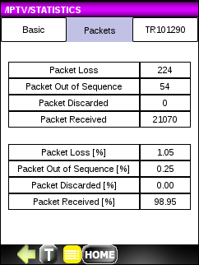
Packets Tab
This tab provides information about the STREAM packet statistics including:

- Packet Loss (Total and % ratio)
- Packet Out of Sequence (Total and % ratio)
- Packet Discarded (Total and % ratio)
- Packet Received (Total and % ratio)

TR101290 Tab
This tab provides information about the TR101290 Priority 1 and Priority 2 stream metrics including:
Priority 1 metrics:
TS Sync Loss, Sync Byte Error, PAT Error, PAT 2 Error, Continuity, Error, PMT Error, PMT 2 Error, PID Error
Priority 2 metrics:
Transport Error, CRC Error, PCR Error, PCR Repetition Error, PCR Discountinuity Error, PCR Accuracy Error, PTS Error, CAT Error,

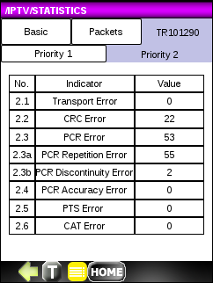
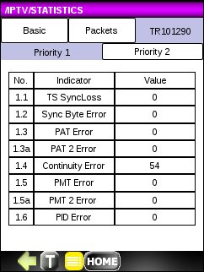

CHANNELS SCAN
Channels SCAN function allows you to connect as the end-device, to emulate Set-Top Box, and check availability of channels (streams) in an IPTV network from a loaded Channel List.
Prior to running Channels Scan, a valid Channel List must be loaded. See previous section Build or Import Channel List.
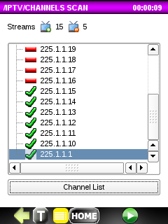
Press on the button to start the Channels Scan. The test stops for the duration of the IGMP delay time defined in the SETUP and checks if the channel connects, displaying it on the list with a green check mark if successful.

